**ASSIGNMENT 3**

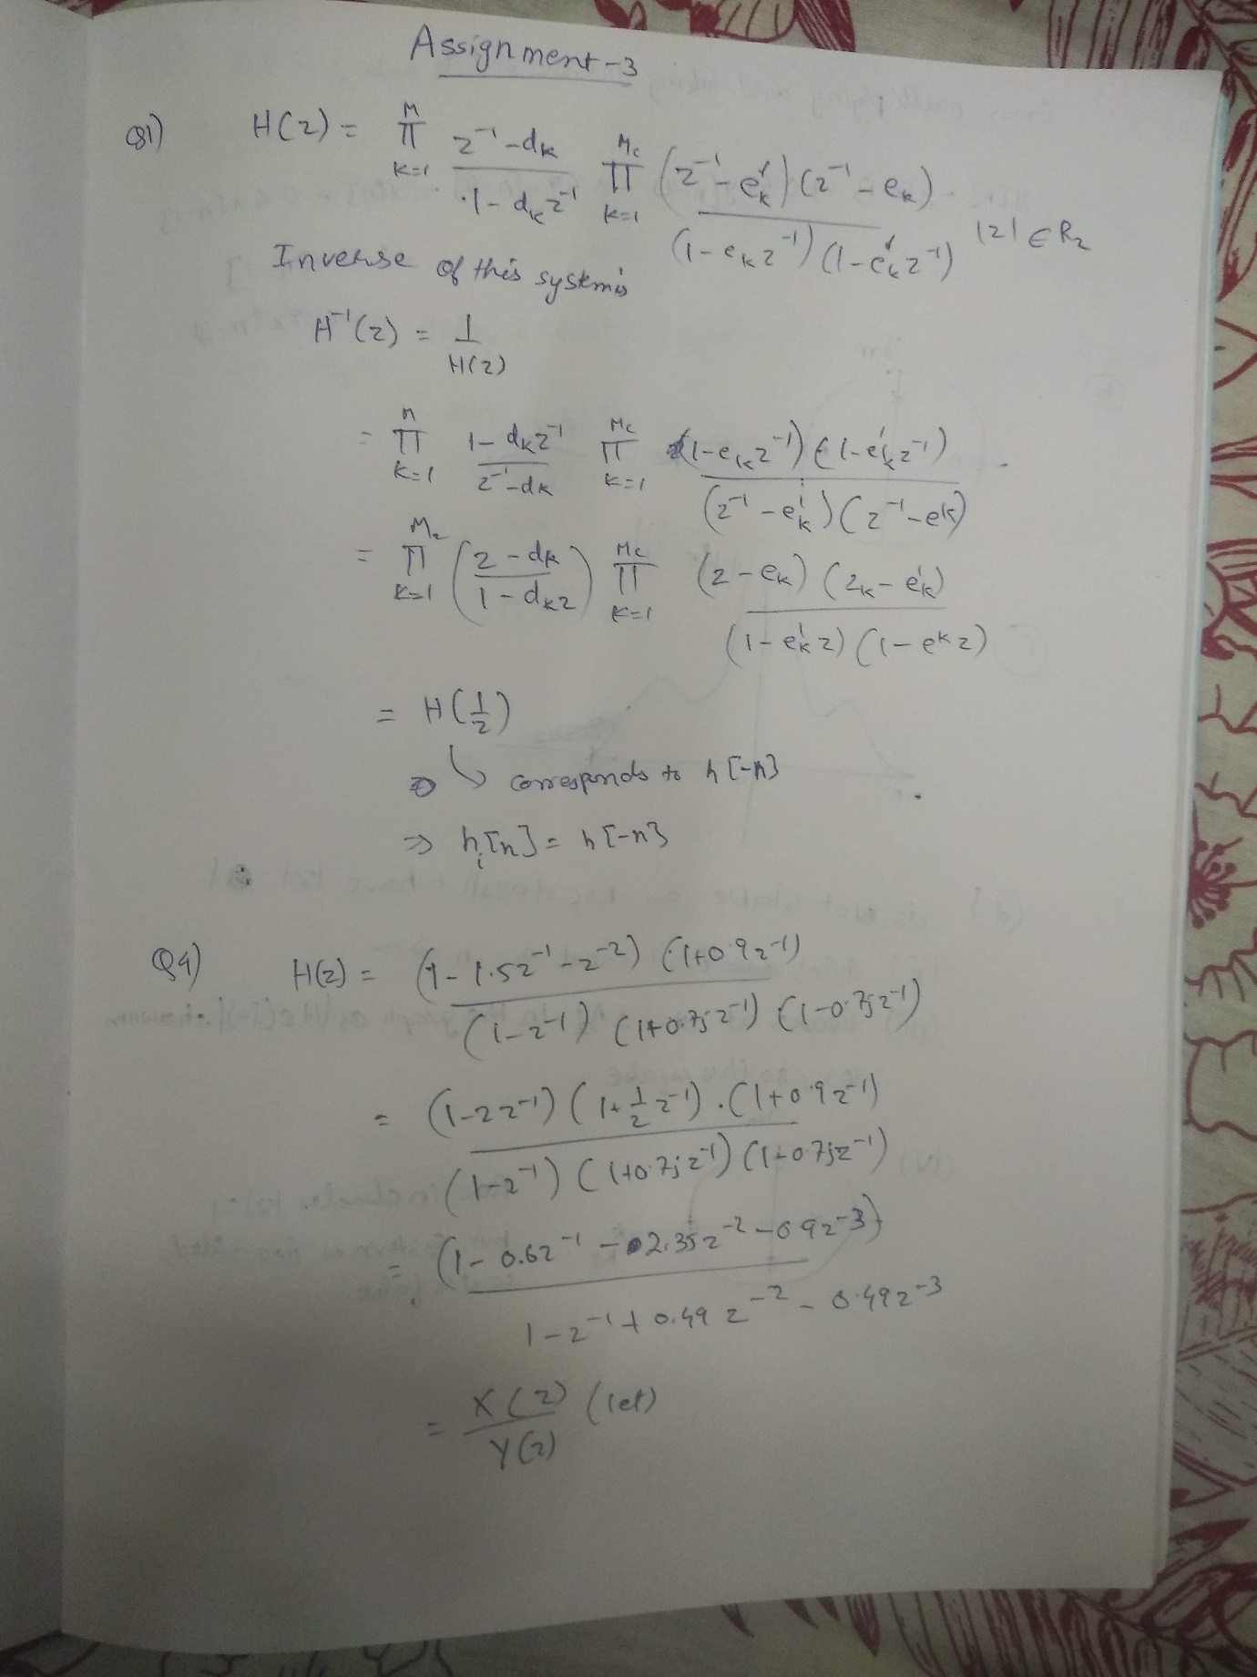

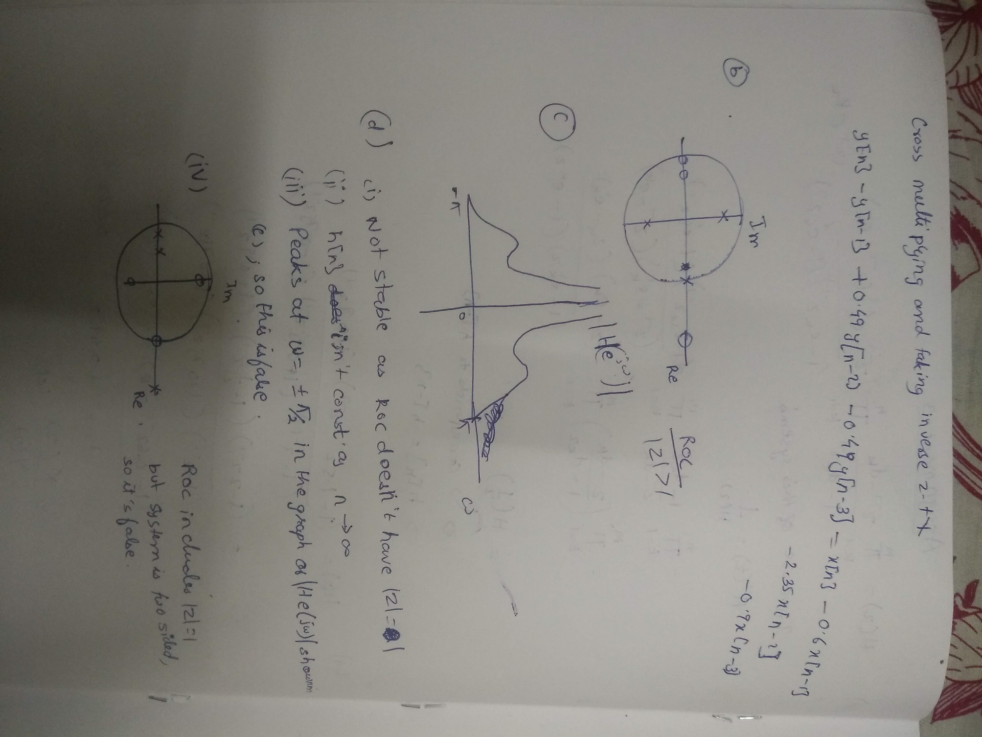

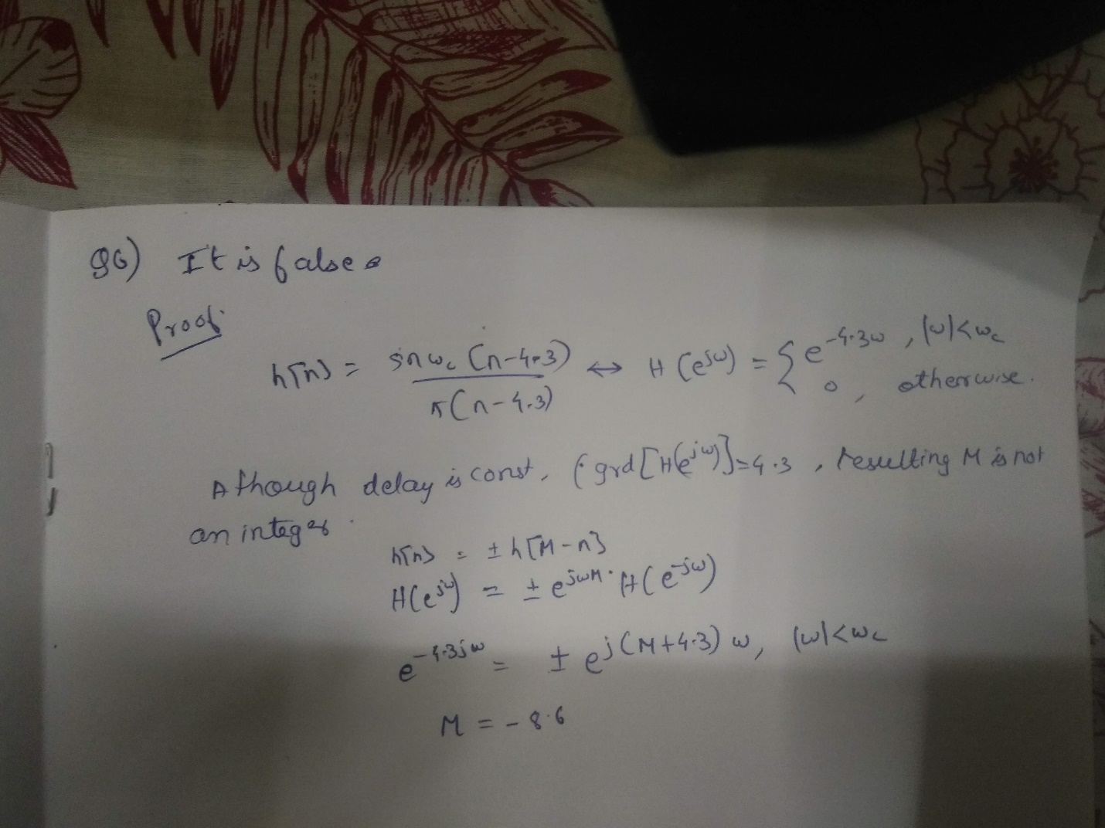

Question 7:

1. **Code:**  
   pkg load signal;

[sound,Fs] = audioread('rhino.wav');

plot(sound);

disp(Fs);

soundsc(sound,44100);

The frequency of sampling was 44100 Hz

**Plot:**

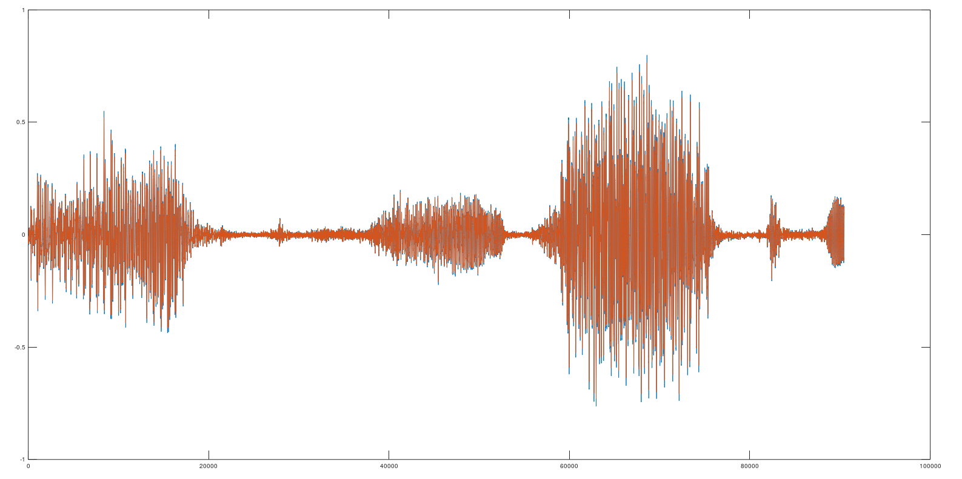

1. **Code:**  
   pkg load signal;

[sound,Fs] = audioread('rhino.wav');

disp(Fs);

channel = sound(:,1);

freqz(channel);  
  
**Plot of channel 1:**  
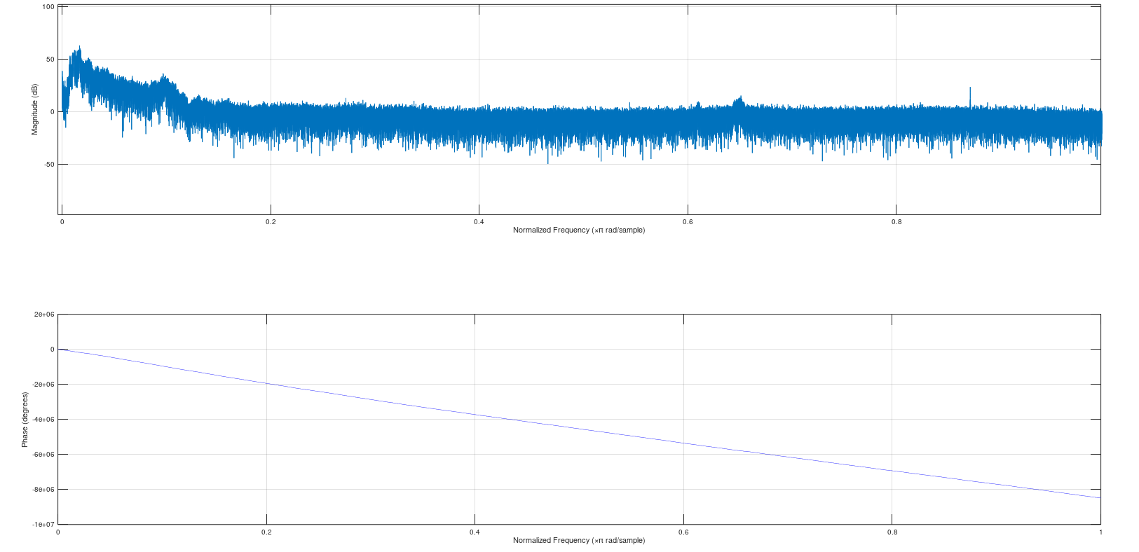

It is inferred that lower frequencies are more dominant.

1. **Code:**  
   pkg load signal;

[sound,Fs] = audioread('rhino.wav');

disp(Fs);

channel = sound(:,1);

sound = sound + 0.01*randn(90462,2);

1. **Code:**

pkg load signal;

[sound,Fs] = audioread('rhino.wav');

sound1=sound;

disp(Fs);

channel = sound(:,1)

sound1 = sound + 0.01*randn(90462,2);

soundsc(sound1,44100);  
  
The sound is not very clear anymore. There is a constant hissing sound now present.

1. **Code:**  
   clc;clear;close all;

pkg load signal;

[sound,Fs] = audioread('rhino.wav');

sound1=sound;

channel = sound(:,1)

sound1 = sound + 0.01*randn(90462,2);

[bf,x] = butter(6,1000*2/44100);

freqz(bf,x);  
  
**Plot of the butterworth filter:**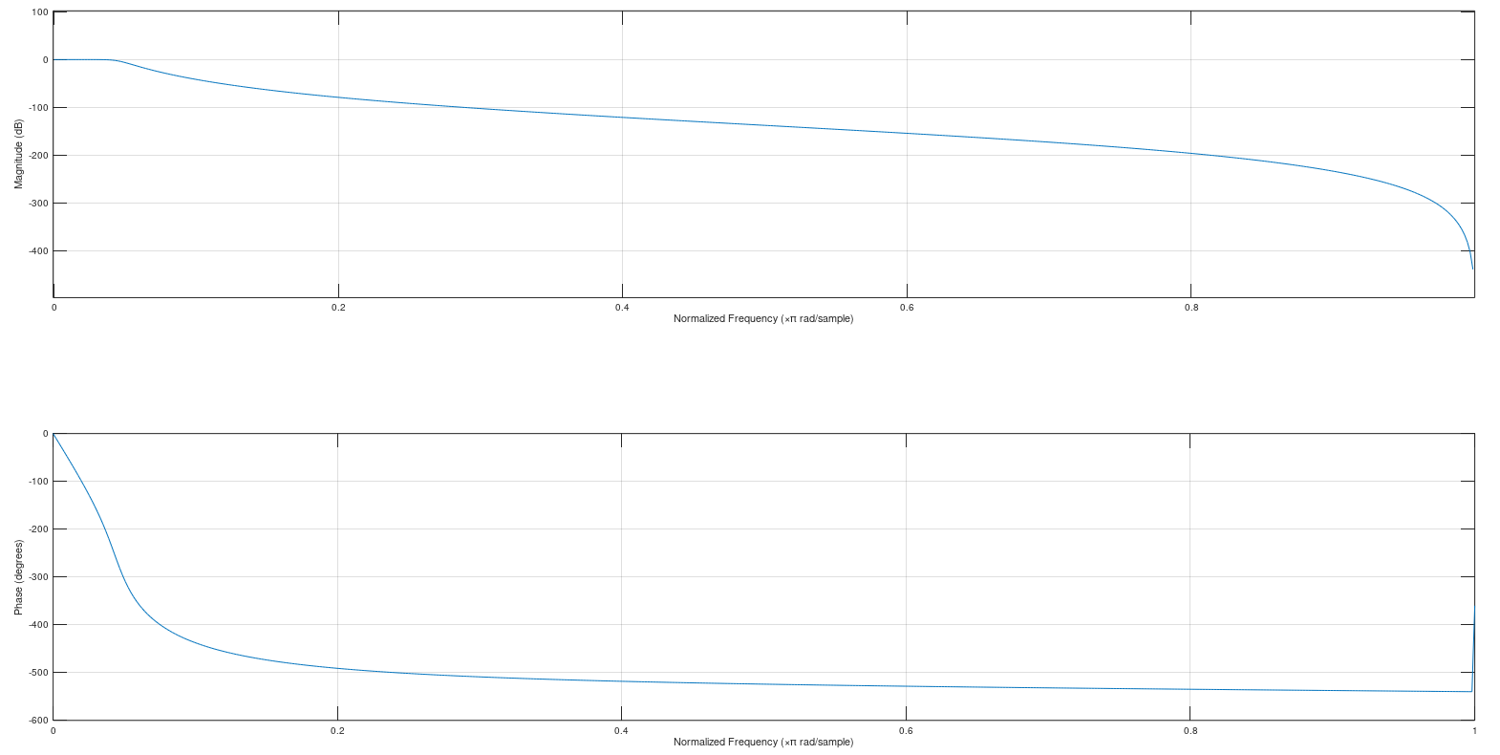

1. **Code:**

clc;clear;close all;

pkg load signal;

[sound,Fs] = audioread('rhino.wav');

sound1=sound;

channel = sound(:,1)

sound1 = sound + 0.01*randn(90462,2);

[bf,x] = butter(6,1000*2/44100);

clean(:,1) = filter(bf,x,sound1(:,1));

clean(:,2) = filter(bf,x,sound1(:,2));

soundsc(clean,44100);

The signal cleans up. This is because we used a low pass filter with a cutoff of 1 kHz. The frequency of the original signal was mostly under 1 kHz, which was passed by the filter but higher frequencies were blocked by the filter.